How to change the list of possible values in a dashboard prompt | 

Yoel Kortick
Senior Librarian

Question:

In a dashboard prompt by "Library Name (Active)" in the "Location" folder of the “Physical Items” subject area all of our libraries appear. We do not want all of the libraries to appear. For example, we do not want the “Resource Sharing Library” and the “Creighton Reinert-Alumni Library” to appear. This is what our dashboard prompt looks like now:

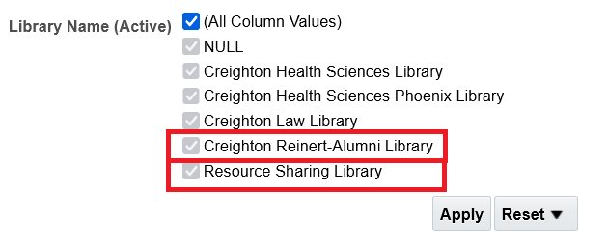

Answer:

This can be done using SQL in the prompt as follows:

ONE

Create the dashboard prompt as described at How to create Dashboard Prompt.

TWO

Edit the prompt.

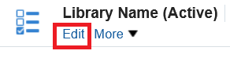

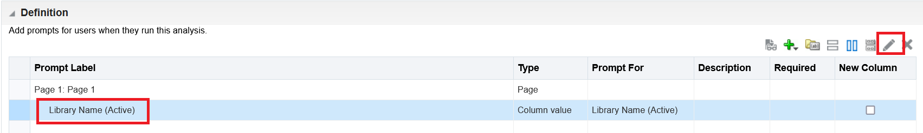

THREE

Open the “options”

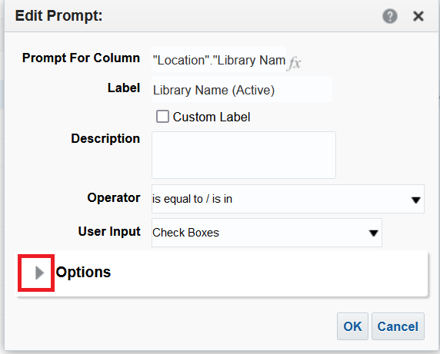

FOUR

Change the field “Check Boxes Values” to “SQL Results”

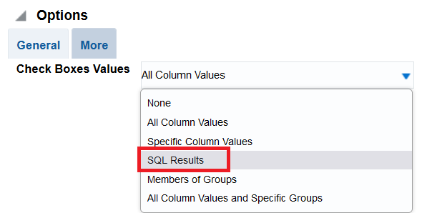

FIVE

Edit the default SQL

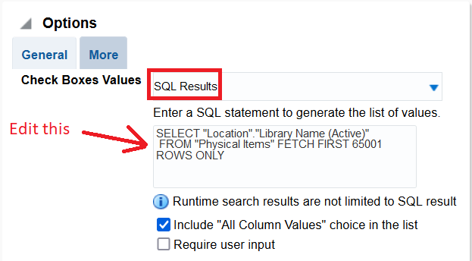

SIX

In our case (for the need described above where we remove certain libraries) we will change this default SQL:

SELECT "Location"."Library Name (Active)"
FROM "Physical Items" FETCH FIRST 65001 ROWS ONLY

To this:

SELECT "Location"."Library Name (Active)"
FROM "Physical Items" where "Location"."Library Name (Active)" NOT IN ('Resource Sharing Library','Creighton Reinert-Alumni Library')
FETCH FIRST 65001 ROWS ONLY

The SQL can be changed as needed to include or not include other libraries.

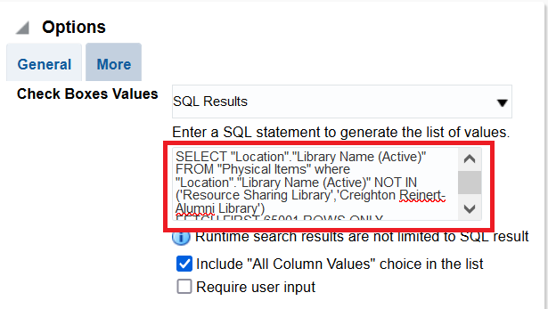

SEVEN

Save the changes

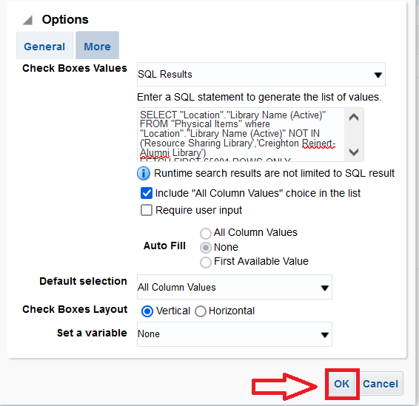

EIGHT

The Prompt now appears as follows. Note that the “Resource Sharing Library” and the “Creighton Reinert-Alumni Library” no longer appear

